**Medicare**

Create a dynamic and responsive Java e-healthcare web application for ordering medicines of different categories.

1. Registration
2. Login
3. Payment gateway
4. Searching
5. Filtering
6. Sorting
7. Dynamic data
8. Responsive and compatible with different devices

Two actors

Admin

SignIn but nog SignUp (fixed username and password like [admin@gmail.com](mailto:admin@gmail.com) and password **admin@123**)

Admin Home Page

Add medicine details, mid(PK auto generate), name,price, url, quantity etc.

Remove medicine, update price and quality and

view all medicine details.

Admin view all customer details

Admin can view all order details.

Searching

Filtering

Sorting

Customer

SignIn and SignUp

Customer Home Page

View the medicine and order the medicine details.

While doing the payment dummy payment gateway

Customer view its own order details.

**User can add the amount**

**Login table**

emailId , password , role

[admin@gmail.com](mailto:admin@gmail.com) admin@123 admin

Medicine table

Mid Name Price URL Quantity etc

Order Table

OId emailId totalammount mid etc

Account Table

Accno amount emailed FK

100 1000

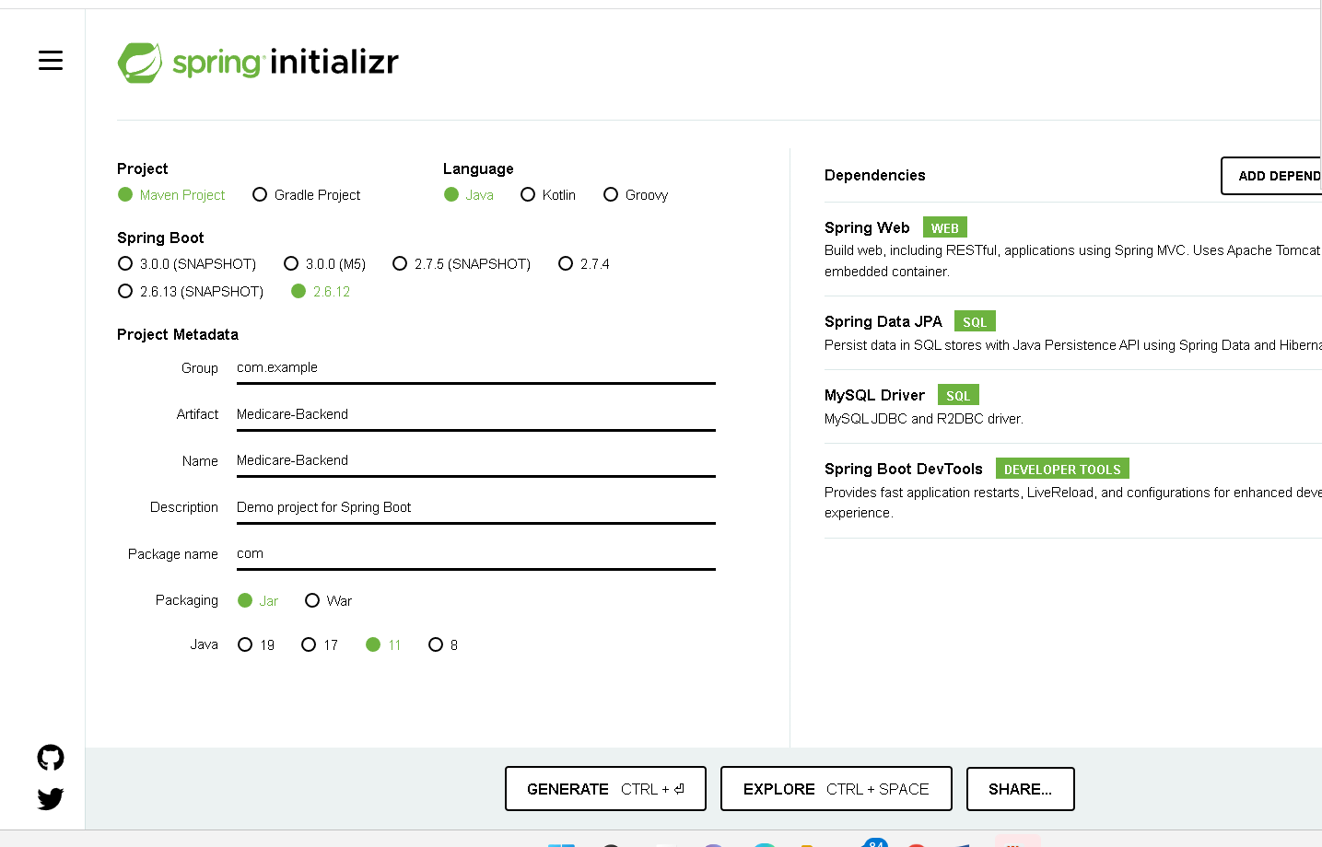

Create the Rest API for Login

Now create angular project

Ng new medicare-frontend

Routing yes

Inside a angular project we have to create

Ng g c login

Ng g c signup

Ng g class login

Ng g s login

Ng g c admindashboard

Ng g c userdashboard

ng g c medicineAdd

ng g class medicine

ng g s medicine

ng g c admin-medicine-retrieve

ng g c user-medicine-retrieve